some notes !

placement of elements in bottom corners.

1. ( left) 'audio' to mute/unmute looping audio

2. (right) 'enquiries' to action mail app. this replaces centred black box.

some other ones that are more thoughts at this point

slight decrease in size of image (for desktop). mobile is okay.

note also: info button (will clarify).

element for sliding through photos because point n.2 above

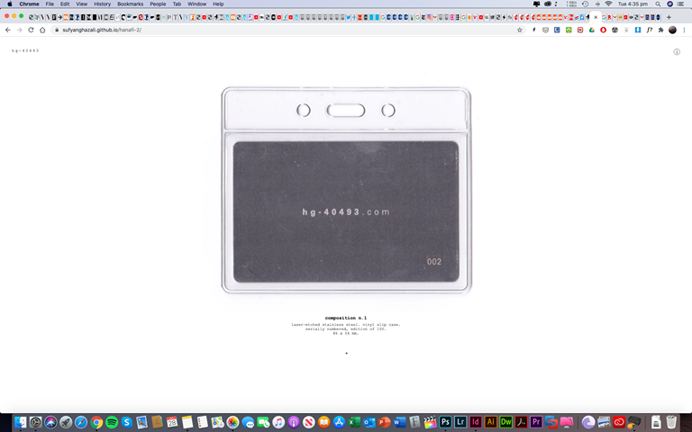

if there's anything unclear whilst you're trying to work on the updates, just ask me